Cable tray report

Cable tray name: DFC001

Cable tray type: Niedax KL 100.603 F

Cable tray purpose: Type C (Red color) for Instrumentation and Control cables

# Cable tray dimensions:

Height: 100 [mm], Width: 600 [mm], Length: 3603.21 [mm],

Weight: 4.738 [kg/m],

# Cables laying on the tray:

|  |  |  |  |  |
| --- | --- | --- | --- | --- |
| **No.** | **Cable name** | **Cable type** | **Cable diameter [mm]** | **Cable weight [kg/m]** |
| 1 | =F2=KF1=GQA1=MAA1=WGA1 | RE-2X(St)H 1x3x1.0mm² (BK) | 6.3 | 0.062 |
| 2 | =F2=KF2=GQA1=MAA1=WDB1 | RE-2X(St)H 1x3x1.0mm² (BK) | 6.3 | 0.062 |
| 3 | =F2=KF3=GPB1=MAA1=WAG1 | RE-2X(St)H 1x3x1.0mm² (BK) | 6.3 | 0.062 |
| 4 | =F2=KF4=GPB1=MAA1=WGA1 | RE-2X(St)H 1x3x1.0mm² (BK) | 6.3 | 0.062 |
| 5 | =H1=LC1=XDC1=WGA1 | Li02YCHXSHX[BK] 18x4 x 0.50mm² | 41.6 | 0.710 |
| 6 | =H1=LC1=XDC2=WGA2 | Li02YCHXSHX[BK] 8x2x 0.25mm² | 26.4 | 0.094 |
| 7 | =H1=LC1=XDC2=WGA1 | Li02YCHXSHX[BK] 8x2x 0.25mm² | 26.4 | 0.094 |
| 8 | =H1=KF1=TAC1=WGA1 | RE-2X(St)H PiMF 8x2x0.75mm² | 14.5 | 0.244 |
| 9 | =H1=KF1=TAC1=WGA2 | RE-2X(St)H PiMF 8x2x0.75mm² | 14.5 | 0.244 |
| 10 | =H1=KF1=TAC1=WGA3 | RE-2X(St)H PiMF 4x2x0.75mm² | 10.7 | 0.148 |
| 11 | =H1=KF1=TAC1=WGA4 | RE-2X(St)H PiMF 4x2x0.75mm² | 10.7 | 0.148 |
| 12 | =H1=KF1=TAC1=WGB1 | CAT.6A S/FTP 4x2xAWG23 | 7.3 | 0.052 |
| 13 | =H1=LC1=UCA1=WGA1 | RE-2X(St)H PiMF 8x2x0.75mm² | 14.5 | 0.244 |
| 14 | =H1=LC1=UCA1=WGA2 | RE-2X(St)H PiMF 4x2x0.75mm² | 10.7 | 0.148 |
| 15 | =H1=LC1=UCA1=WGA3 | RE-2X(St)H PiMF 4x2x0.75mm² | 10.7 | 0.148 |
| 16 | =H1=LC1=UCA1=WGB2 | CAT.6A S/FTP 4x2xAWG23 | 7.3 | 0.052 |
| 17 | =H2=KF1=TAC1=WGA1 | RE-2X(St)H PiMF 8x2x0.75mm² | 14.5 | 0.244 |
| 18 | =H2=KF1=TAC1=WGA2 | RE-2X(St)H PiMF 8x2x0.75mm² | 14.5 | 0.244 |
| 19 | =H2=KF1=TAC1=WGA3 | RE-2X(St)H PiMF 4x2x0.75mm² | 10.7 | 0.148 |
| 20 | =H2=KF1=TAC1=WGA4 | RE-2X(St)H PiMF 4x2x0.75mm² | 10.7 | 0.148 |
| 21 | =H2=KF1=TAC1=WGB1 | CAT.6A S/FTP 4x2xAWG23 | 7.3 | 0.052 |
| 22 | =H2=LC1=UCA1=WGA1 | RE-2X(St)H PiMF 8x2x0.75mm² | 14.5 | 0.244 |
| 23 | =H2=LC1=UCA1=WGA2 | RE-2X(St)H PiMF 4x2x0.75mm² | 10.7 | 0.148 |
| 24 | =H2=LC1=UCA1=WGA3 | RE-2X(St)H PiMF 4x2x0.75mm² | 10.7 | 0.148 |
| 25 | =H2=LC1=UCA1=WGB2 | CAT.6A S/FTP 4x2xAWG23 | 7.3 | 0.052 |
| 26 | =H4=KF1=TAC1=WGA1 | RE-2X(St)H PiMF 8x2x0.75mm² | 14.5 | 0.244 |
| 27 | =L2=LC1=WGB2 | CAT.6A FRNC FC 4x2xAWG23 | 8.7 | 0.091 |
| 28 | =H4=KF1=TAC1=WGA2 | RE-2X(St)H PiMF 8x2x0.75mm² | 14.5 | 0.244 |
| 29 | =H4=KF1=TAC1=WGA3 | RE-2X(St)H PiMF 4x2x0.75mm² | 10.7 | 0.148 |
| 30 | =H4=KF1=TAC1=WGA4 | RE-2X(St)H PiMF 4x2x0.75mm² | 10.7 | 0.148 |
| 31 | =H4=KF1=TAC1=WGB1 | CAT.6A S/FTP 4x2xAWG23 | 7.3 | 0.052 |
| 32 | =K1=JK1=WGB3 | CAT.6A FRNC FC 4x2xAWG23 | 8.7 | 0.091 |
| 33 | =K1=JK3=WGB1 | CAT.6A FRNC FC 4x2xAWG23 | 8.7 | 0.091 |
| 34 | =L2=JL1=WHA1 | 4G 62.5/125μm OM1 | 9.6 | 0.122 |
| 35 | =L2=LC1=WGB1 | CAT.6A FRNC FC 4x2xAWG23 | 8.7 | 0.091 |
| 36 | =L2=LC1=WGB3 | CAT.6A FRNC FC 4x2xAWG23 | 8.7 | 0.091 |
| 37 | =L2=LC1=WGB4 | CAT.6A S/FTP 4x2xAWG23 | 7.3 | 0.052 |
| 38 | =L2=LC1=WHA1 | 4G 62.5/125μm OM1 | 9.6 | 0.122 |
| 39 | =L3=LC1=WGB1 | CAT.6A FRNC FC 4x2xAWG23 | 8.7 | 0.091 |
| 40 | =L3=LC1=WGB2 | CAT.6A FRNC FC 4x2xAWG23 | 8.7 | 0.091 |
| 41 | =L3=LC1=WGB3 | CAT.6A FRNC FC 4x2xAWG23 | 8.7 | 0.091 |
| 42 | =L3=LC1=WGB4 | CAT.6A S/FTP 4x2xAWG23 | 7.3 | 0.052 |
| 43 | =L4=LC1=WGB1 | CAT.6A FRNC FC 4x2xAWG23 | 8.7 | 0.091 |
| 44 | =L4=LC1=WGB2 | CAT.6A FRNC FC 4x2xAWG23 | 8.7 | 0.091 |
| 45 | =L4=LC1=WGB3 | CAT.6A FRNC FC 4x2xAWG23 | 8.7 | 0.091 |
| 46 | =L4=LC1=WGB4 | CAT.6A S/FTP 4x2xAWG23 | 7.3 | 0.052 |
| 47 | =L5=JL3=WHA2 | 4G 62.5/125μm OM1 | 9.6 | 0.122 |
| 48 | =P1=LC1=WGA2 | RE-2X(St)H PiMF 4x2x0.75mm² | 10.7 | 0.148 |
| 49 | =P1=LC1=WGA3 | RE-2X(St)H PiMF 4x2x0.75mm² | 10.7 | 0.148 |
| 50 | =P1=LC1=WGA4 | RE-2X(St)H PiMF 4x2x0.75mm² | 10.7 | 0.148 |

# Weight calculations:

## Supports weight calculations:

The supports weight calculations depend on the distance between the supports based on the tray length and the count. For “KL 100.603 F” type the maximal distance between two supports is 1.5 meters. For trays that the length is less than 1.5 meters, we have 2 pieces of supports. For trays that the length is bigger than 20% from the base 1.5 meters, there is additional support.

Supports count: (3.603 * 1000) / 1.5 ≈ 3.402 = 4 [pcs.],

Weight per piece: 5.416 [kg]

The total weight of the supports is calculated by the count of the supports, multiplied by the weight per piece:

Supports total weight: 4 * 5.416 = 21.664 [kg]

The total weight per meter is calculated by division of the tray length and the total weight of the supports:

Supports weight load per meter: 21.664 / (3603.21 * 1000) = 6.012 [kg/m]

## Tray own weight calculations:

Tray weight load per meter is calculated by the sum of cable tray weight and support weight per meter:

Tray weight load per meter: 4.738 + 6.012 = 10.75 [kg/m]

Total tray weight is calculated by combining the own weight per meter with added supports weight per meter, then multiplied by the tray total length.

Tray total own weight: 10.75 * (3603.21 / 1000) = 38.735 [kg]

## Cables on tray weight calculations:

Cables weight load per meter is calculated by the sum of cables weight per meter:

Cables weight load per meter: 0.062 + 0.062 + 0.062 + 0.062 + 0.71 + 0.094 + 0.094 + 0.244 + 0.244 + 0.148 + 0.148 + 0.052 + 0.244 + 0.148 + 0.148 + 0.052 + 0.244 + 0.244 + 0.148 + 0.148 + 0.052 + 0.244 + 0.148 + 0.148 + 0.052 + 0.244 + 0.091 + 0.244 + 0.148 + 0.148 + 0.052 + 0.091 + 0.091 + 0.122 + 0.091 + 0.091 + 0.052 + 0.122 + 0.091 + 0.091 + 0.091 + 0.052 + 0.091 + 0.091 + 0.091 + 0.052 + 0.122 + 0.148 + 0.148 + 0.148 = 6.805 [kg/m]

Total weight of all the cables on the tray is the sum of the cables weights.

Total weight on the tray: 6.805 * (3603.21 / 1000) = 24.52 [kg]

## Total weight:

Total weight load per meter: 10.75 + 6.805 = 17.555 [kg/m]

Total weight: 38.735 + 24.52 = 63.255 [kg]

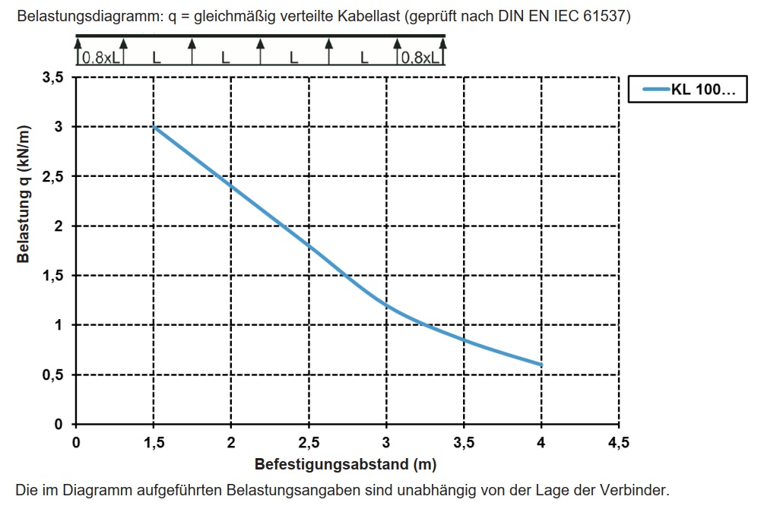

Picture 1. – Load per meters diagram regarding the distance between the supports.

# Free space calculations:

All trays “KL 100.603 F” type are ladder type trays. Rung spacing 300 [mm], with continuously perforated side rails, with riveted, upwardly open rungs made of C-profiles.

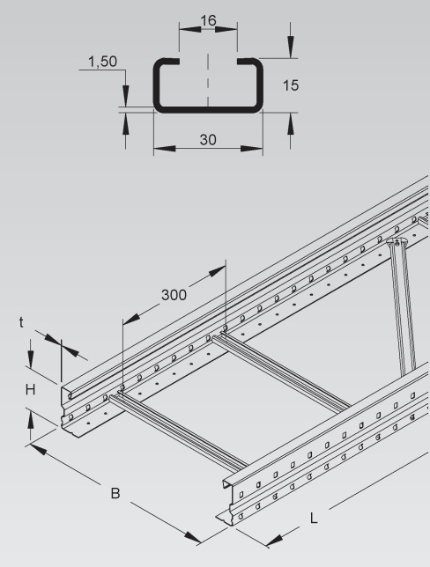

Picture 2. – Cable tray type overview.

Tray board height is 100 [mm], but the C-profiles occupies a part of the volume space. So, the useful height for the tray is 100 – 15 = 85 [mm]. The free space on the cable tray is considered to be the not occupied from cables part on the bottom of the tray, calculated between the cables bundles laid on the side and the opposite tray board or the free space between the cables bundles laid on the both sides of the tray for LV and Instrumentation and Control type of trays.

## Space occupied by cables:

The occupied space by the cables can be calculated by the sum of the diameters of the cables on the bottom of the tray with an additional spacing of 1 [mm] between the cables for cable ties:

Total sum cables of diameters: (41.6 * 1) + 1 * 1 + (26.4 * 1) + 1 * 1 + (14.5 * 2) + 1 * 2 + (10.7 * 3) + 1 * 3 + (8.7 * 2) + 1 * 2 + (7.3 * 2) + 1 * 2 + (6.3 * 2) + 1 * 2 = 186.7 [mm]

## Cable tray free space:

The percentage of free width is calculated by subtracting the total sum of cables diameters from the cable tray width, then divided by the cable tray width and converted to percentages:

Percentage of free width: 100 - (186.7 / 600 * 100) = 68.88 [%]

